ACLRS — HTML Validation
ID | Area | Page | File | Initial Result | Issue Identified | Action/Fix | Final Result
HTML-01 | Main Site | Main/Index Page | index.html | Validation issues identified | HTML validation issues were identified during the initial W3C check. | The identified HTML issues were corrected, and the page was revalidated. | Valid – No errors or warnings
HTML-02 | Authentication | Login | pages/auth/login.html | Validation issues identified | HTML validation issues were identified during the initial W3C check. | The identified HTML issues were corrected, and the page was revalidated. | Valid – No errors or warnings
HTML-03 | Authentication | Staff Registration | pages/staff/register.html | Validation issues identified | HTML validation issues were identified during the initial W3C check. | The identified HTML issues were corrected, and the page was revalidated. | Valid – No errors or warnings
HTML-04 | Patient Portal | Dashboard | pages/patient/dashboard.html | Validation issues identified | HTML validation issues were identified during the initial W3C check. | The identified HTML issues were corrected, and the page was revalidated. | Valid – No errors or warnings
HTML-05 | Clinician Portal | Dashboard | pages/clinician/clinician_dashboard.html | Validation issues identified | HTML validation issues were identified during the initial W3C check. | The identified HTML issues were corrected, and the page was revalidated. | Valid – No errors or warnings
HTML-06 | Admin Portal | Dashboard | pages/admin/admin_dashboard.html | Validation issues identified | HTML validation issues were identified during the initial W3C check. | The identified HTML issues were corrected, and the page was revalidated. | Valid – No errors or warnings
HTML-07 | Laboratory Manager | Dashboard | pages/staff/manager/dashboard.html | Validation issues identified | HTML validation issues were identified during the initial W3C check. | The identified HTML issues were corrected, and the page was revalidated. | Valid – No errors or warnings
HTML-08 | Specimen Portal | Main Page | pages/staff/specimen/index.html | Validation issues identified | HTML validation issues were identified during the initial W3C check. | The identified HTML issues were corrected, and the page was revalidated. | Valid – No errors or warnings
HTML-09 | Technician | Technician Portal | pages/staff/technician/index.html | Validation issues identified | HTML validation issues were identified during the initial W3C check. | The identified HTML issues were corrected, and the page was revalidated. | Valid – No errors or warnings
HTML-10 | Reception | Reception Portal | pages/staff/reception/index.html | Not Valid – 1 error and 1 warning | W3C identified an invalid “<div>” element used as a child of a “<button>” elment. A “<section>” element with “id=”app”” was also identified as lacking an appropriate heading. | No code changes were implemented. The identified error and warning were documented for future improvement, while the existing implementation was retained during the current testing phase. | Not Valid -1 error and 1 warning remain.

The Evidence of HTML Validity:
- HTML-01
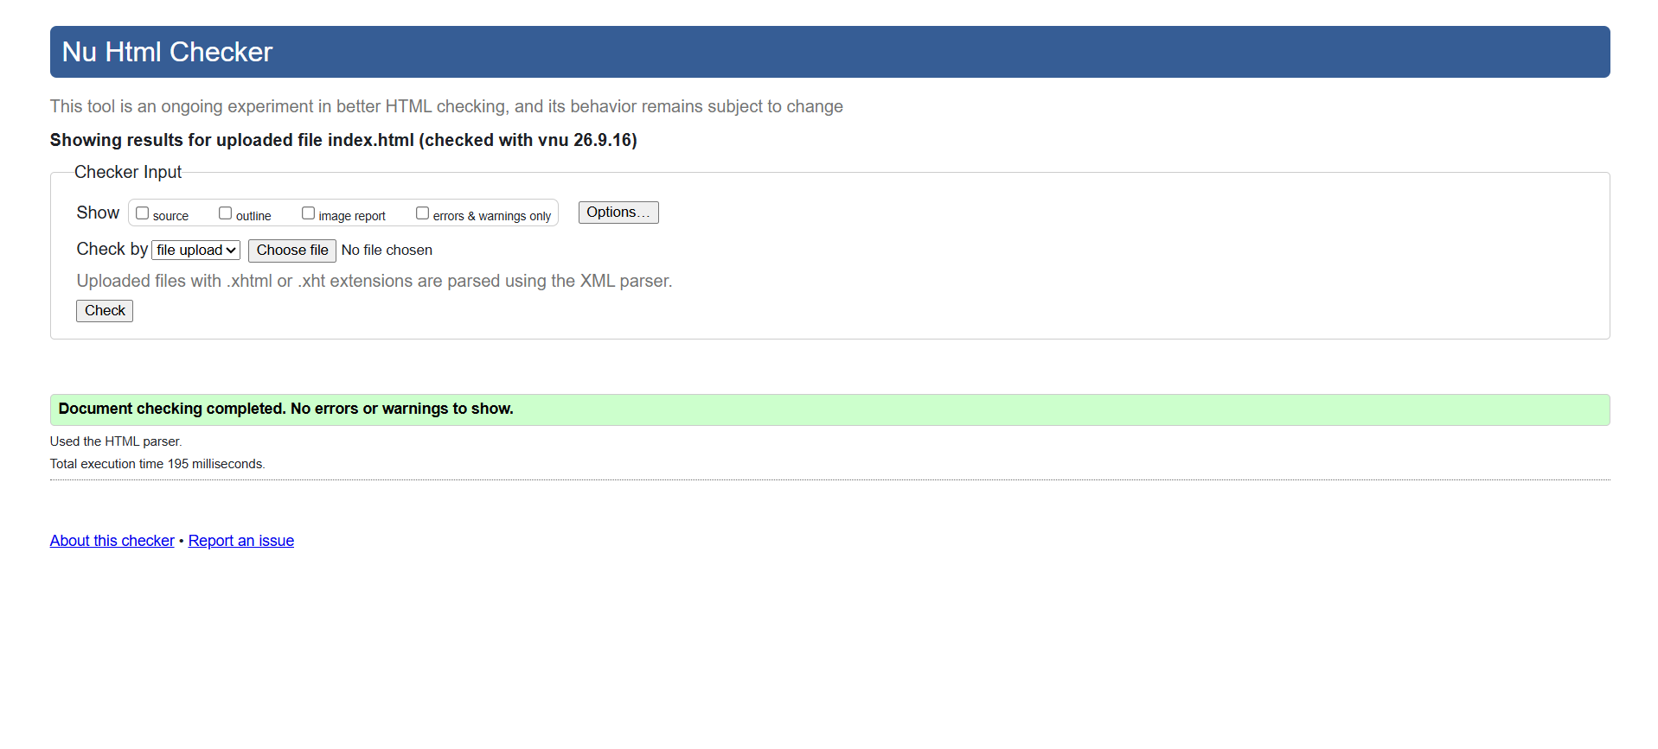
- HTML-02
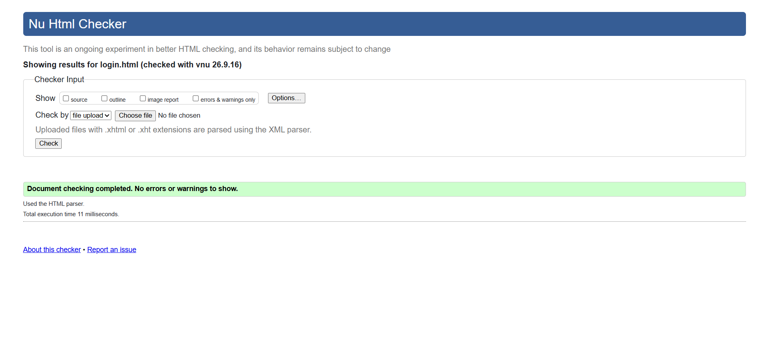
- HTML-03
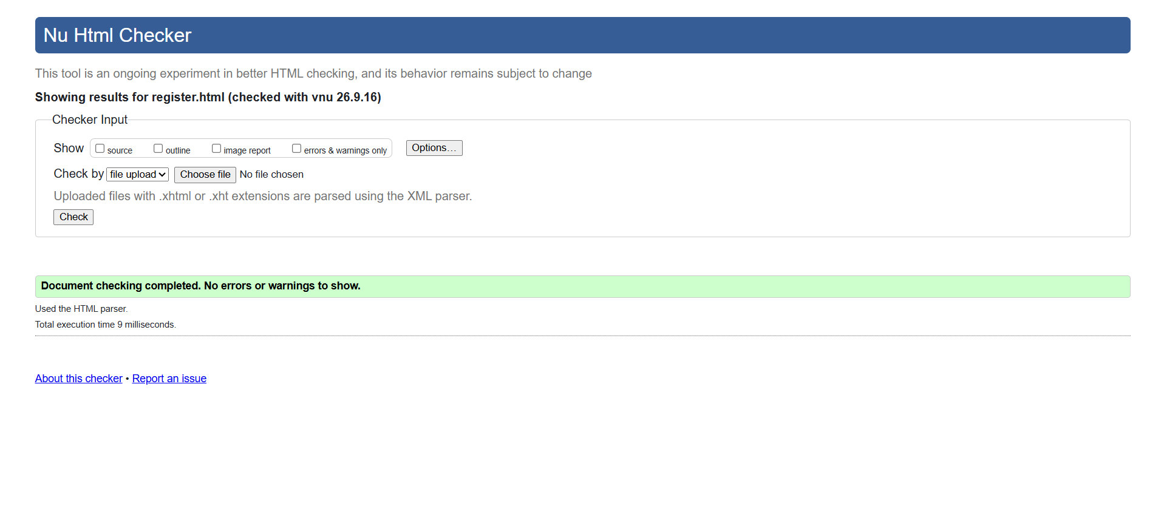
- HTML-04
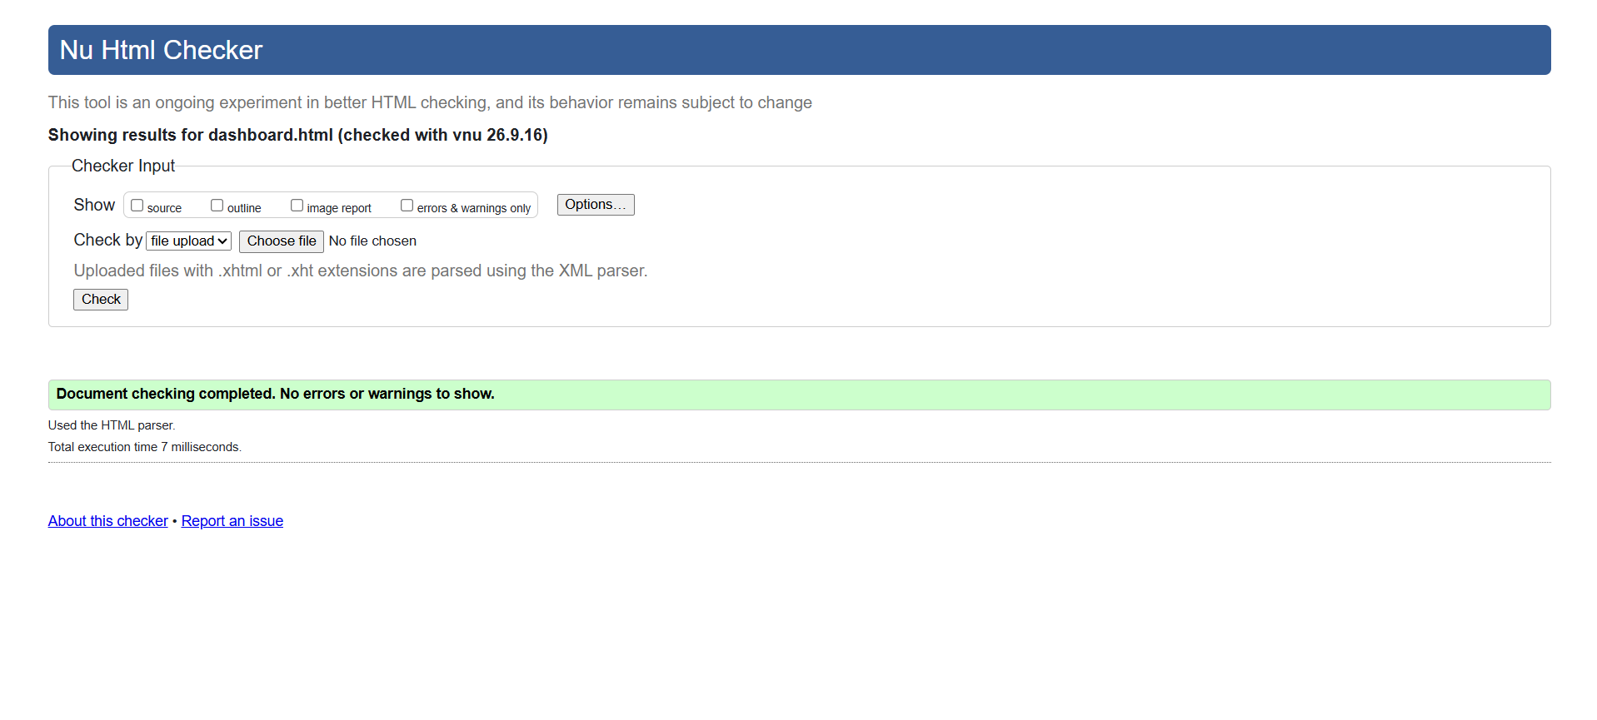

- HTML-05
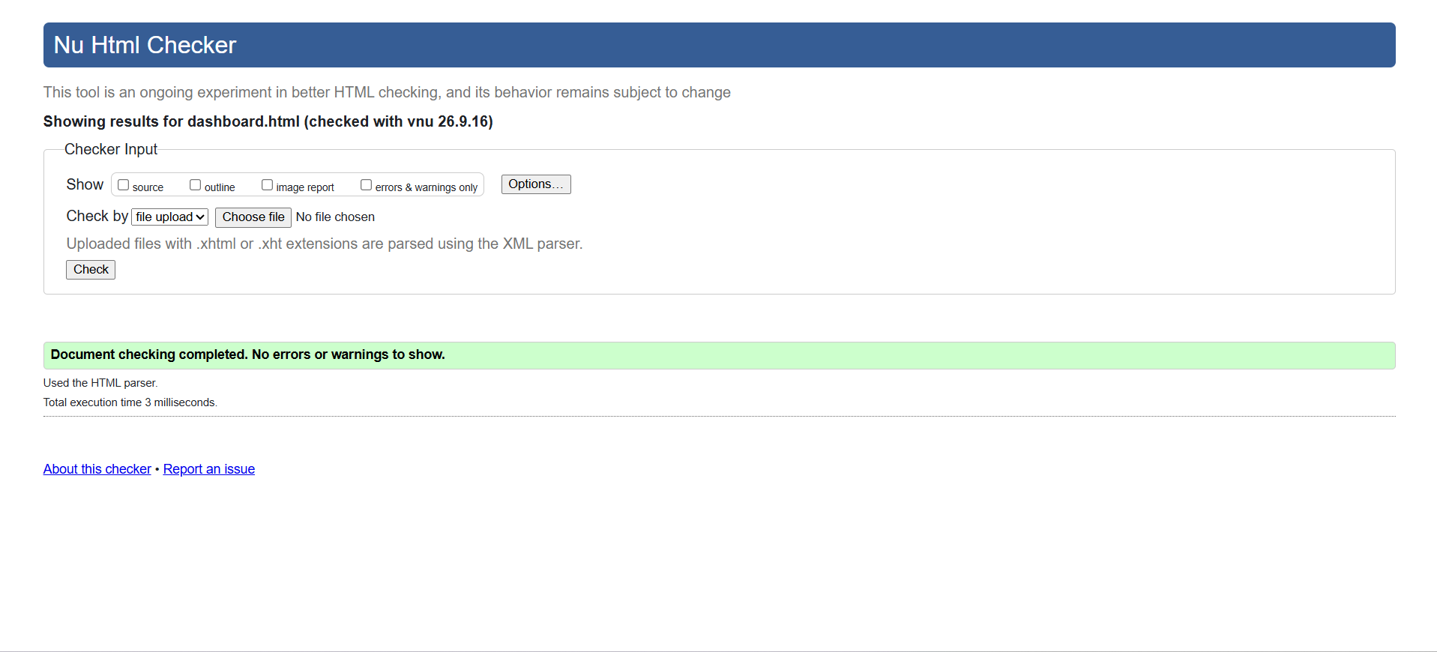

- HTML-06
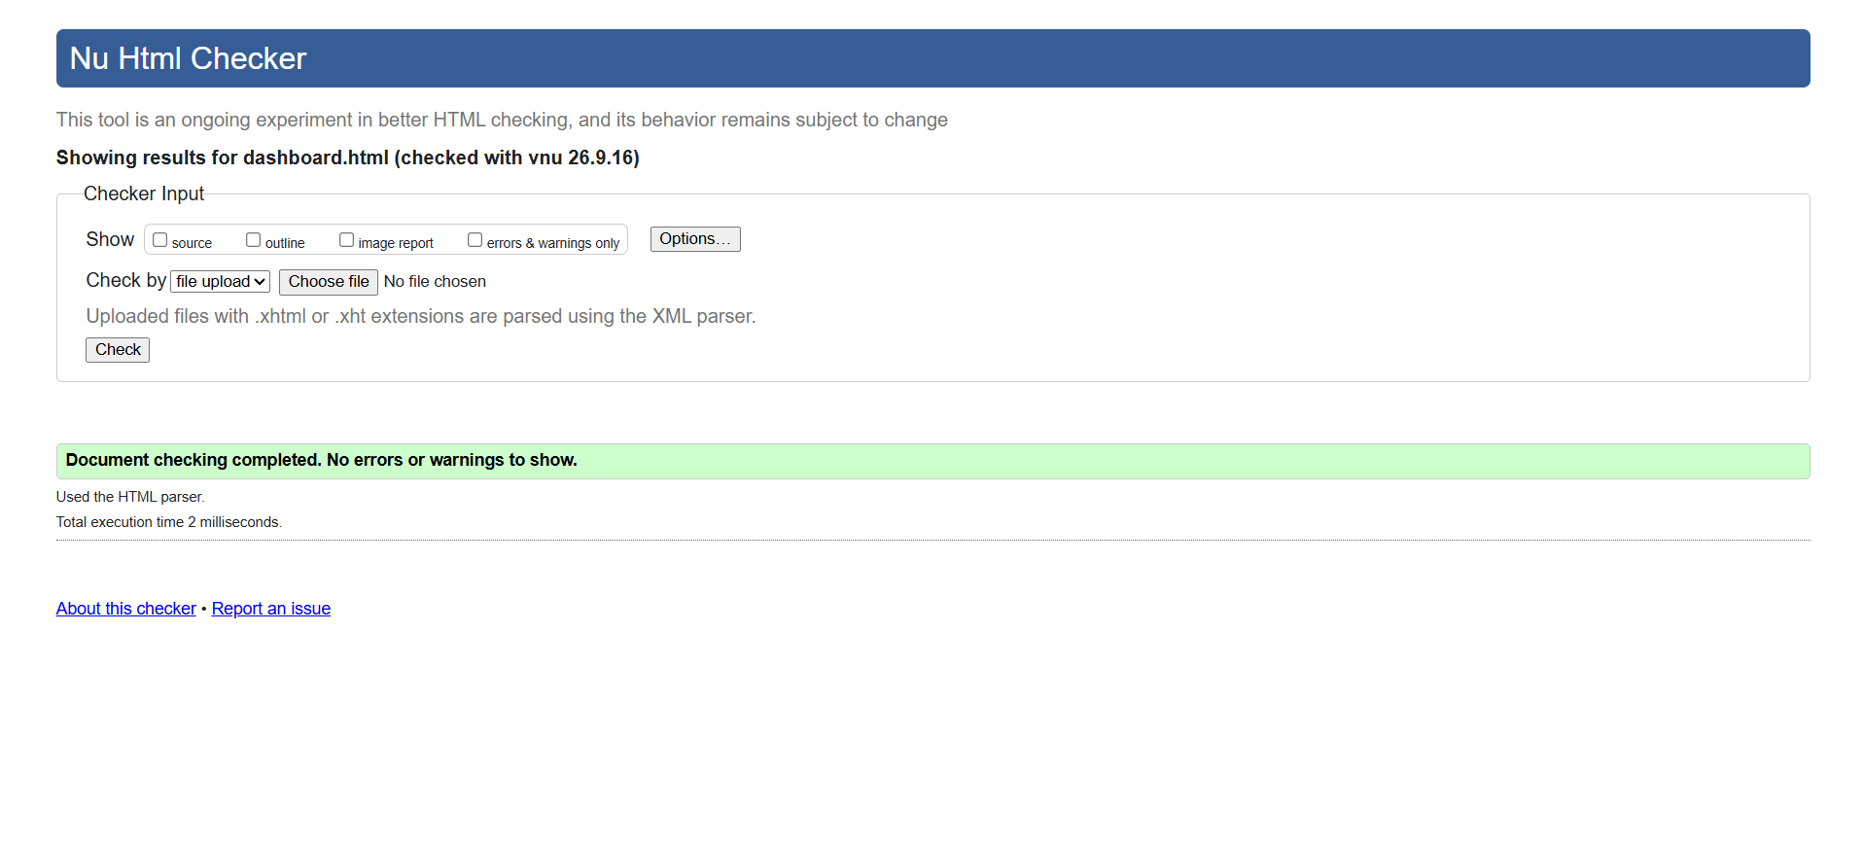

- HTML-07
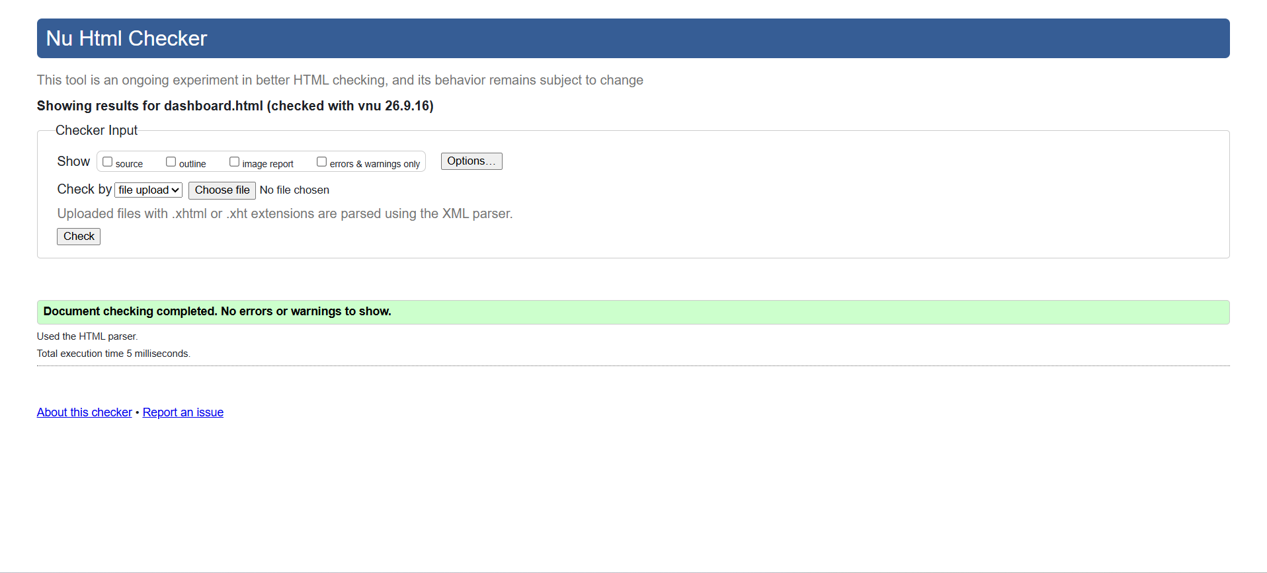

- HTML-08
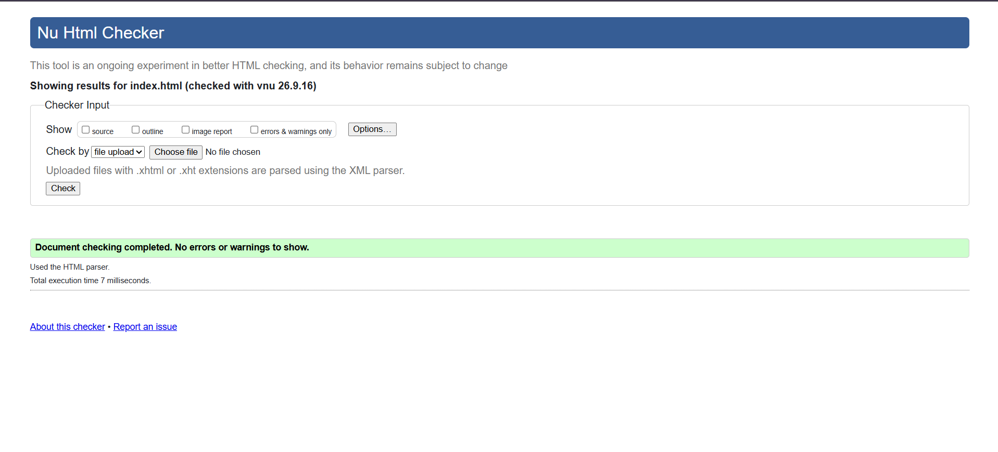
- HTML-09
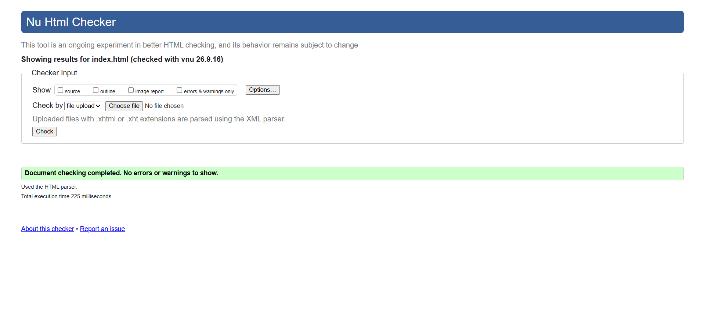
- HTML-10
